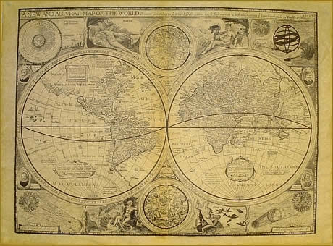

Congratulations fearless explorer!

The King and Queen hereby grant you permission to embark on this journey. We are convinced you will bring honor and riches to our kingdom.

We will provide you with everything you need to complete your journey including a ship, crew and all the necessary provisions. In order for you to receive your reward, you will create an Explorer’s Notebook. Upon your safe return, we will examine your Notebook. If we deem your quest successful, you will be handsomely rewarded.
The requirements of the Explorer’s Notebook are attached to this letter.

Good luck on your journey!

The King and Queen

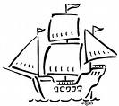
Explorer’s Notebook

Your Explorer’s Notebook is due April 3rd.

It must contain the following items:

- A cover with your name (explorer name) and a picture of you (the explorer).

- Travel Route(s) – map tracing the voyage(s) from the sponsoring country to your destination (include a legend with dates)

- A summary of at least 3 paragraphs including information about you (see attached list of possible explorers)
  - Name
  - Important background/personal information (childhood, trade/profession, how he became interested in sailing)
  - Nationality (if you are sailing for a country other than your native country, include this information too)
  - Purpose of expedition (reasons for this trip, who is financing the trip)

- A description and a drawing of a tool or instrument that helped you on your voyage (see attached list of possible Explorer Tools).

- A drawing of the flag of the Monarchy to plant on all land claimed.

- A letter to the monarch (King or Queen) sharing what you found and explaining:
  - What you discovered and why it was important
  - Any difficulties you encountered
  - Any other interesting information

- A certificate from the monarch to you. This certificate will recognize you for your impact to the early settlement of the Americas. This will require some thought. Consider the following:
- Did your exploration help later explorers? How?
- Did your exploration impact Native Americans? How?
- Did your exploration lead to future development?

- A bibliography listing the sources you used.
The Process

There are 4 main parts to this project:

Step 1: Collect information

Once you have selected the explorer you will represent, you will gather information from books and websites about the explorer. Record your notes on index cards or using the attached template.

https://www.enchantedlearning.com/explorers/

https://exploration.marinersmuseum.org/

https://www.history.com/topics/exploration

Be sure to record the sources (books, URLs or other resources) of your information.

Step 2: Write the paragraph and letter

Submit your rough draft to me by Friday, March 22nd. Final drafts may be typed or neatly handwritten.

Step 3: Write and assemble the Explorer Notebook

After you have gathered all your information you will write the documents needed for the Explorer’s Notebook. Use your rubric as a guide! Your Notebook should be neat and represent your best work. Please assemble the items in your Notebook in the order they are listed on page 2 of this document.

Step 4: Present your Notebook to the class

Possible Explorers - you will be assigned an explorer
- Leif Ericson
- Marco Polo
- Vasco da Gama
- Christopher Columbus
- Amerigo Vespucci
- Ferdinand Magellan
- Vasco Nunez de Balboa
- John Cabot
- Sir Francis Drake
- Henry Hudson
- Juan Ponce de Leon
- Francisco Vasquez de Coronado
- Francisco Pizarro
- Hernando Cortes
- Hernando De Soto
- Rene-Robert de La Salle
- Jacques Cartier
- Samuel de Champlain

Possible Explorer Tools – you may find others in your research
- Astrolabe
- Chip board
- Compass
- Cross Staff
- Hour Glass
- Chronometer
- Quadrant
- Traverse Board

Explorer Rubric
Task | 3 | 2 | 1 | Score
Explorer Information | Identifies and provides all important information about the explorer | Identifies most important information about the explorer but some information is missing. | Provides few details about the explorer.
Map | Map of voyage is accurate and well marked. | Map of voyage is accurate but difficult to follow. | Map of voyage is inaccurate.
Explorer’s Tool | Description and drawing of tool is accurate and complete. | Description and drawing of tool is mostly accurate or is missing some information. | Description and drawing of tool is inaccurate or is missing most important information.
Flag | Flag is accurate, includes a legend and drawn neatly | Flag is mostly accurate, includes a legend and drawn neatly | Flag is inaccurate and/or sloppy, legend is inaccurate or missing or map is not drawn
Letter to King | Letter explains the importance of the exploration | Letter somewhat explains the importance of the exploration. | Letter doesn’t accurately explain the importance of the exploration.
Certificate from Monarch | Certificate thoughtfully identifies positive or negative consequences of explorations | Certificate attempts to identify positive or negative consequences of explorations but isn’t completely accurate | Certificate does not identify positive or negative consequences of explorations
Grammar / Spelling | There are no grammar or spelling errors. | There are no more than 3 grammar or spelling errors. | There are 4 or more spelling errors.
Organization / Appearance | Notebook is organized and presented well. | Notebook is somewhat organized and presented well. | Notebook is not organized well and/or presentation is poor.
Oral Presentation | Consistently uses eye contact, refers to notes, speaks with satisfactory volume and inflection | Minimal eye contact, mostly reads notes, speaks with uneven volume and little inflection | No eye contact, reads notes, speaks with uneven volume and little inflection
Bibliography | Sources for all printed and online references (including images) are cited using correct format. | Sources for all printed and online references (including images) are cited but format is incorrect. | Sources for some printed and online references (including images) are cited and format is incorrect.
Grade /comments:

Explorer Research

Explorer’s name:

Nationality (and country sponsoring explorer, if different):

Born/Died:

Interesting/important background information: (examples: Who influenced the explorer? What training did the explorer have?)

Reasons for the trip/Where did explorer sail:

What did explorer discover (examples: peoples, plants, lands, animals, agriculture)?

Interesting Facts:

How did explorer contribute to development of the Americas?

