Name ______________ Date: 12/ /18 Assessment Date: 12/ /18
Applied Study Guide: Parent Signature Required at the End
*If questions or blanks appear on this document, you are expected to complete them*
- Vocabulary:

- State of Matter: The physical form of a substance

- Solid: The densest form of matter for any substance. Solids generally have a definite size and shape. The molecules that make up solids vibrate, but do not allow solids to change shape
Ice is the solid form of water. Give another example: _____________________.

- Liquid: A state of matter that tends to flow freely. Typically liquids are capable of taking on the shape of their container. Particles are in constant motion. Give an example: ______________________

- Gas: The least dense form of matter for a given substance. Particles in gas are moving around rapidly and tend to be quite far apart. A state of matter that does not have a definite shape or volume. Give an example: _____________________

- Plasma: Matter that is heated to extreme temperatures where molecules come apart and produce light. Stars and fluorescent light bulbs are examples of plasma. Give another example: ______________________

- Subatomic Particles: are particle smaller than an atom; the protons, neutrons, and electrons.

7. Ion: an atom or molecule with an electric charge due to the loss (or gain) of one or more electrons. Try and draw an ion in the space below.

- States of Matter:

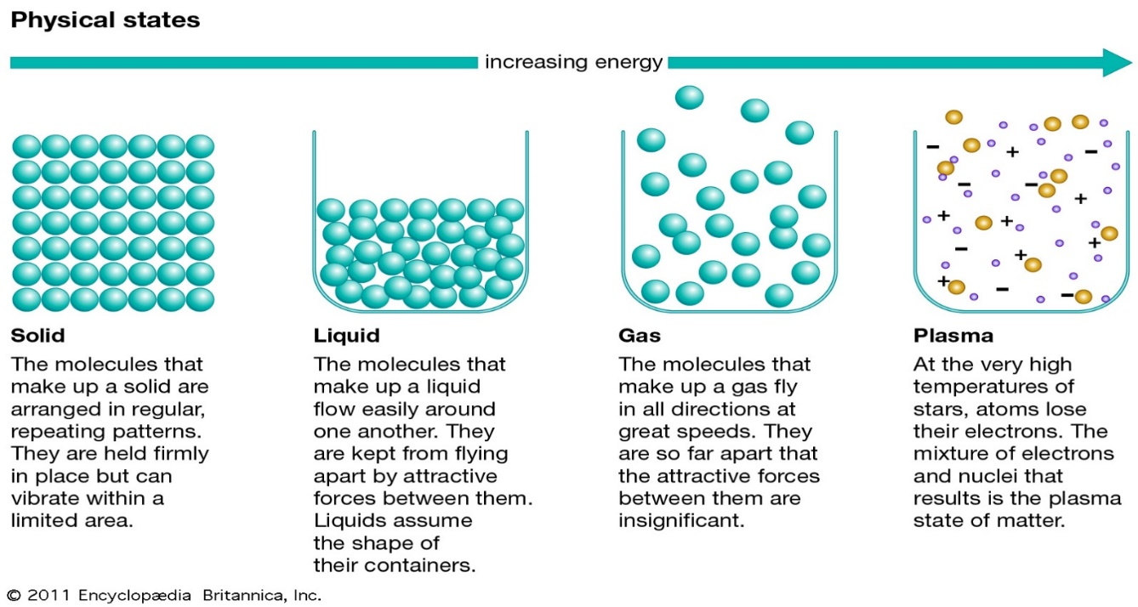
8. How are penguins like ice molecules? And Why? (Reread Matter Changes) 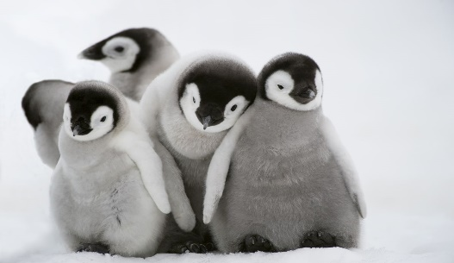

9. Also from Matter Changes, What does the broken toy car represent?__________________
Explain.______________________________________________________________________

10 . Sunlight is a source of __________________ and ______________________ energy

11. The increase and decrease of energy applied to a substance will effect the state of matter
What kind of relationship would this be? ______________ and _________________.

- ATOMS
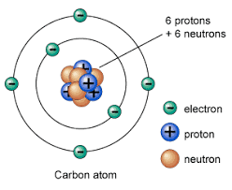

12. Number the following particles in order from smallest to biggest; 1, 2, 3, 4, 5
Atoms, Electrons, Neutrons, Molecule, Nucleous
________ ________ ________ ________ ________
1. 2. 3. 4. 5.
Smallest Biggest

13. In an Atom, what are the Subatomic particles (hint: the little ones in the picture above)?
a. ________________b. ____________________c. ___________________

14. When substances receive extreme amounts of energy what happen to their electrons?
_________________________________________________________________________

15. You can make equations that show what happens to substances when energy is added or taken away.
a. example: gas + energy= plasma
b. solid + energy = ________
c. ______+ energy=gas
d. Liquid - energy=______
e. Plasma-energy=________

16. The molecular structure of liquid particles alow it to _________________________
Because________________________________________________________________
17. The molecular structure of gas particles allow it to___________________________
Because________________________________________________________________
18. The molecular structure of a solid allows it to_______________________________
Because________________________________________________________________
19. What super power does PLASMA have? (Think lights, stars, sun)_________________

- Graph

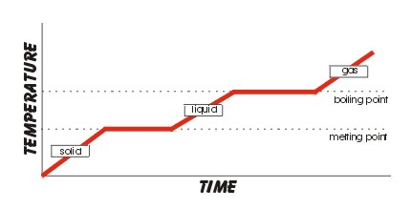
19. What type of graph is shown? ____________________________________________
20. What is the title of the horizontal axis? _____________________________________
21. Look carefully at the graph as a whole and think of a title and write it on the line.
22. Does the graph tell us what substance is changing states? ____. What type of substance could it be? _________________________________________________________________

To prepare for the quiz: 1. reread, 2. rewrite, 3. recreate illustrations, and 4. have an ongoing list of questions that you add to as they come up. Don’t wait until the last minute to review the material.

Parent’s Signature________________________________________________________

